MINOR PROJECT REPORT

ON

**A cognitive moderator Chatbot for Anger detection**

*Submitted in partial fulfillment of requirements for the degree of*

**Bachelor of Technology (B. Tech)**

in

**Computer Science and Engineering**



*Submitted by*:

**ANJUM ADNAM ALI**

**MANI SANKAR NATH**

**RUSHIKA SAHA**

**TWINKLE KAUR**

**School of Engineering and Technology**

**Department of Computer Science and Engineering**

**The Assam Kaziranga University**

**November 2019**

Understanding of the project:

In this project, we created a chatbot using Watson services. The chatbot flow was enhanced by using tone analyzer to detect anger and ugly messages.

We learnt how to:

* Create a chatbot using the IBM Watson Assistant service.
* Identify tone of speech with Tone Analyzer.
* Using APIs of Watson services and integrating it with the web application.

In this project, we have developed a chatbot for a café which is capable of detecting emotions such as anger via analysis of the tone of the response by user to the chatbot. Firstly, we built our chatbot on Watson assistant. We learnt what are intents, entities and dialogs and how to use them effectively to build our chatbot. In one of the intents we used a variable to sent the text response to the tone analyser. If the tone is detected to be anger it gives us a custom response that is displayed to the user.

***Watson Assistant***, uses Watson AI [machine learning](https://searchenterpriseai.techtarget.com/definition/machine-learning-ML) (ML) and natural language understanding ([NLU](https://searchenterpriseai.techtarget.com/definition/natural-language-understanding-NLU)). It has three major components:

* **Intents** are purposes or goals that are expressed in a customer's input, such as answering a question . By recognizing the intent expressed in a customer's input, the Watson Assistant service can choose the correct dialog flow for responding to it.
* **Entities** represent information in the user input that is relevant to the user's purpose. If intents represent verbs, entities represent nouns .
* ***Dialog*** uses the intents, entities as well as system variables and custom variables that are identified in the user's input, plus context from the application, to interact with the user and ultimately provide a useful response.

The IBM Watson ***Tone Analyzer*** service uses linguistic analysis to detect emotional and language tones in written text. The service can analyze tone at both the document and sentence levels. This service uses linguistic analysis to detects joy, sadness, fear, anger and confidence.

The user enters enters a message in the UI which sends the text to the Watson assistant in JSON format. A response is then returned based on the message it receives in JSON format. This response is then printed in the UI. If the message provided by the user enters the intent customized with the tone analyzer and anger is detected a custom response of apology is printed on the UI. If the message enters the slag entities it gives a warning is printed on the UI. All the response related to different intents and entities and even variables are present in the dialog section.

The flow of our project is as follows:

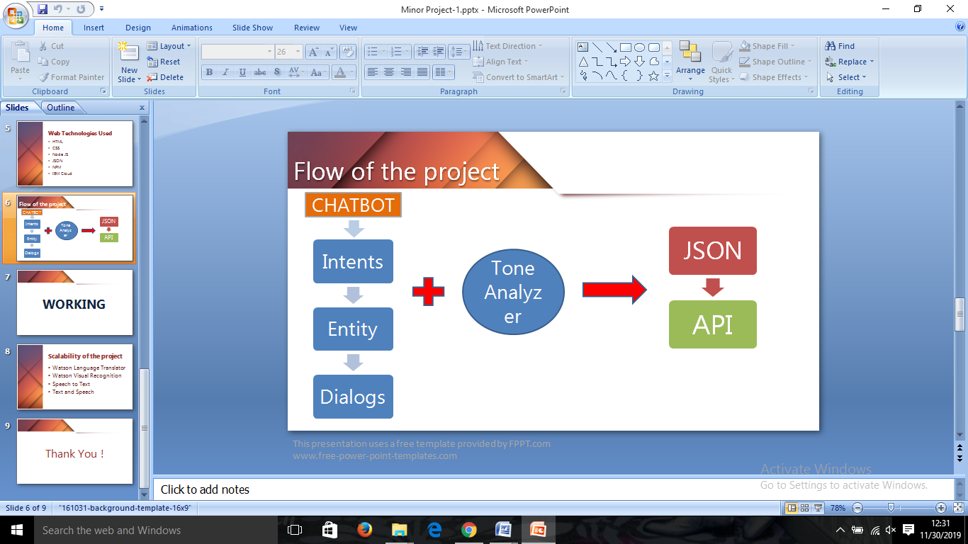

Technology Stack – Application Development Architecture:

* HTML, CSS: HTML, CSS are used for user interface part. Hypertext Markup Language (HTML) is the standard markup language for documents designed to be displayed in a web browser.

Cascading Style Sheets (CSS) is a stylesheet language used to describe the presentation of a document written in HTML or XML. CSS describes how elements should be rendered on screen, on paper, in speech, or on other media.

* Node js for backend.
* Watson assistant as the API.
* Tone analyzer as the API.
* JSON (Java script object notation).
* npm (node package manger).
* IBM cloud for the deployment of the project.

Datasets:

Not applicable

Scalability Scope of the Project:

The application can scaled is the following ways:

* Watson Language Translator can be used in the chatbot to enable it to communicate in different languages.
* Watson Visual Recognition for explicit image removal.
* Speech to Text can be used to make the bot voice enabled.
* Text and Speech can be used to get the response in audio format.